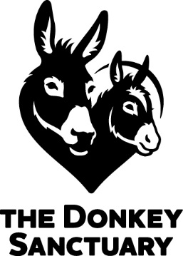

Lottery Exclusion Form
Please exclude me from The Donkey Sanctuary lottery with immediate effect and do not make any direct contact with myself during my exclusion period.

(We will exclude you for the requested period [minimum 6 months] from the date of the form. Beyond that date you will have to request to be removed from the exclusion register, or your exclusion will continue).

Name……………………………………………………..

Address………………………………………………….
………………………………………………….
………………………………………………….

Membership number (if applicable) …………………

The initial period that you wish to be excluded:

6 months 1 year 2 years 3 years 4 years 5 years

Signature…………………………………………

Date………………

Please return this form to: -
The Donkey Sanctuary Weekly Lottery
Sterling Management Centre Ltd
Furness Gate
Furness Business Park
Barrow-in-Furness
Cumbria, LA14 2PE

